AI-Based Student Dropout Prediction and Counselling System | Sprint Documentation

AI-Based Student Dropout Prediction and Counselling System
Day-by-Day Project Documentation
June 01 — June 13,2026

DAY-1 | PROJECT TITILE FINALIZATION | June 01,2026
Project Title:
AI-Based Student Dropout Prediction and Counselling System
Overview:
The AI-Powered Student Dropout Prediction and Counselling System is a web-based application designed to help educational institutions identify students who are at risk of dropping out. The system analyses student data such as attendance, academic performance, and engagement using Machine Learning techniques to predict dropout risk. Based on the prediction results, personalized counselling recommendations are provided to support students and improve retention rates.
Scope:
• Collect and analyze student academic, attendance, and behavioral data.
• Predict students who are at risk of dropping out using Artificial Intelligence and Machine Learning techniques.
• Classify students into different risk categories such as Low, Medium, and High risk.
• Provide personalized counselling recommendations for students identified as at risk.
• Support educational institutions in improving student retention and academic performance through data-driven insights.

DAY-2 | REQUIREMENT GATHERING | June 02,2026
Problem Statement:
Many educational institutions rely on manual observation and traditional academic monitoring methods to identify students who may discontinue their studies. These approaches are often reactive and may fail to detect early warning signs of dropout. As a result, institutions may lose opportunities to provide timely support and intervention. There is a need for an intelligent system that can analyze student data, predict dropout risk at an early stage, and recommend appropriate counseling measures to improve student success and retention.
Functional Requirements:
1: User Authentication
The system shall allow administrators, faculty members, and counsellors to securely log in and access the system based on their roles.
2: Student Data Management
The system shall enable users to add, update, view, and manage student academic, attendance, and behavioural records.
3: Dropout Risk Prediction
The system shall analyse student data using AI and Machine Learning algorithms to predict the likelihood of student dropout.
4: Risk Classification
The system shall categorize students into different risk levels such as Low, Medium, and High risk based on prediction results.
5: Counselling Recommendation
The system shall provide personalized counselling suggestions and intervention strategies for students identified as being at risk of dropping out.
6: Progress Monitoring
The system shall track and monitor the progress of students after counselling sessions and interventions.
7: Dashboard and Reporting
The system shall display prediction results, student statistics, and reports through an interactive dashboard.

DAY-3 | OBJECTIVE DEFINITION | June 03,2026
Primary Objectives:
• To develop an AI-Based Student Dropout Prediction and Counseling System that identifies students at risk of dropping out and provides timely counseling recommendations to improve student retention and academic success.
Specific Objectives:
• To collect and analyze student academic, attendance, and behavioral data.
• To identify key factors that contribute to student dropout.
• To predict dropout risk using Artificial Intelligence and Machine Learning techniques.
• To classify students into different risk levels such as Low, Medium, and High risk.
• To provide personalized counseling recommendations for at-risk students.
• To monitor student progress after counseling interventions.
• To assist educational institutions in making data-driven decisions for improving student retention and performance.

DAY-4 | USER & MODULE IDENTIFICATION | June 04,2026

User List
1. Admin
Role:
- Monitor dropout predictions.
- View reports and analytics.
- Manage counselors and system settings.
Permissions:
- Full access to the system.
- Add, update, and delete records.
- View prediction results.
2. Counselor
Role:
- Review students identified as at-risk.
- Provide counseling recommendations.
- Track student progress after intervention.
Permissions:
- Access student profiles.
- View prediction results.
- Update counseling records.
3. Student
Role:
- View personal academic details.
- Check risk status (if allowed).
- Access counseling recommendations.
Permissions:
- View own information only.
- Access personalized recommendations.
- Export reports

Module List
Authentication Module
- Provides secure user login and logout.
- Verifies user identity.
- Controls access based on user roles.
Student Management Module
- Stores student personal and academic information.
- Maintains student records.
- Allows updating and managing student details.
Data Collection Module
- Collects attendance records.
- Collects academic performance data.
- Gathers information required for prediction.
Dropout Prediction Module
- Analyzes student data using Machine Learning.
- Predicts the probability of student dropout.
- Identifies students at risk.
Risk Assessment Module
- Classifies students into risk categories.
- Highlights high-risk students.
- Supports early intervention.
Recommendation/Counseling Module
- Generates personalized recommendations.
- Suggests actions to improve student performance.
- Provides guidance for at-risk students.
Dashboard & Analytics Module
- Displays prediction results visually.
- Monitors student performance trends.
- Provides statistical insights and analytics.
Report Generation Module
- Generates student performance reports.
- Creates dropout risk reports.

DAY-5 | USE CASE DIAGRAM | June 05,2026
  - 5.1-USE CASE DIAGRAM
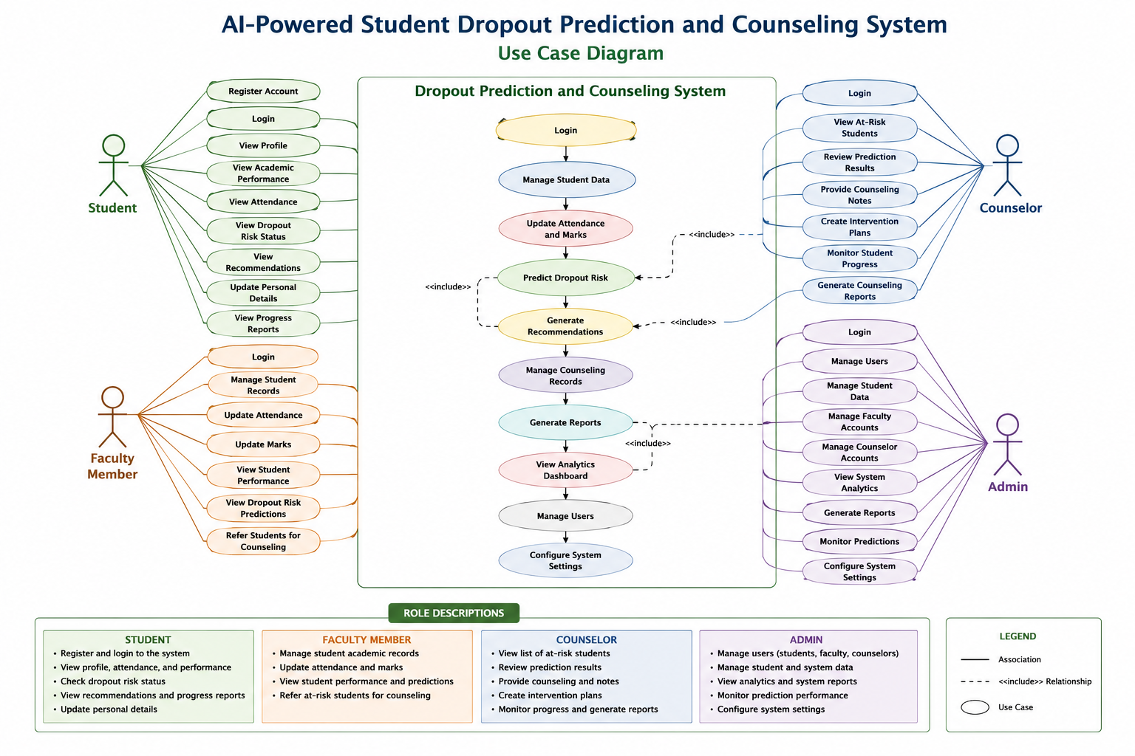
  - 5.2-USE CASE DESCRIPTION
Use-case ID | Use-cases | Actor | Description
UC-01 | Login | All Users | Allows users to access the system.
UC-02 | Manage student data | Admin,faculty | Add,update and view student records.
UC-03 | Predict Dropout risk | System | Predict dropout probability usingAI
UC-04 | Provide counselling | counsellor | Provide recommendations to at-risk students
UC-05 | Generate Reports | Admin | Genrate report and analytics

DAY-6 | DATABASE REQUIREMENT ANALYSIS | June 06,2026
  - 6.1-DataBase Requirements:
Database requirements define the types of data that must be stored, organized, and managed by the system to support its functionality.
For the AI-Based Student Dropout Prediction and Counseling System:
• The database should store user information for Administrators, Faculty Members, Counselors, and Students.
• The database should maintain student academic records, attendance records, and behavioral data.
• The database should store AI-generated dropout prediction results and risk classifications.
• The database should maintain counseling records, recommendations, and intervention details.
• The database should support report generation and student progress tracking.

  - 6.2-Identified Tables:

Table no | Requirements | Description
- 1. | - User Management | - Store details of Administrators, Faculty Members, Counselors, and Students.
- 2. | - Student Information | - Maintain student personal and academic details.
- 3. | - Attendance Records | - Store student attendance data for analysis.
- 4. | - Academic Performance | - Store marks, grades, CGPA, and semester results.
- 5. | - Dropout Prediction data | - Store AI prediction results and risk levels.
- 6. | - Counselling Records | - Maintain counseling sessions and recommendations.
- 7 | - Progress Tracking | - Track student improvement after counseling.
- 8. | - Report and Analytics | - Store generated reports and statistical data.
- 9. | - Security and Access Control | - Ensure role-based access and data protection.

Table 1 : Students
• Student ID
• Name
• Email
• Department
• Year of Study
• CGPA/GPA
• Contact Number
Table 2 : Attendance
• Attendance ID
• Student ID
• Attendance Percentage
• Semester
Table 3 : Academic Performance
• Record ID
• Student ID
• Marks
• Assignment Status
• Semester
Table 4 : Predictions
• Prediction ID
• Student ID
• Risk Level (Low/Medium/High)
• Prediction Score
• Prediction Date
Table 5 : Recommendations
• Recommendation ID
• Student ID
• Recommendation Details
• Generated Date
Table 6 : Counseling Records
• Counseling ID
• Student ID
• Counselor ID
• Counseling Notes
• Follow-up Status
Table 7 : Users
• User ID
• Username
• Email
• Password
• Role (Admin, Faculty, Counselor, Student)

DAY-7 | ER DIAGRAM | June 07,2026

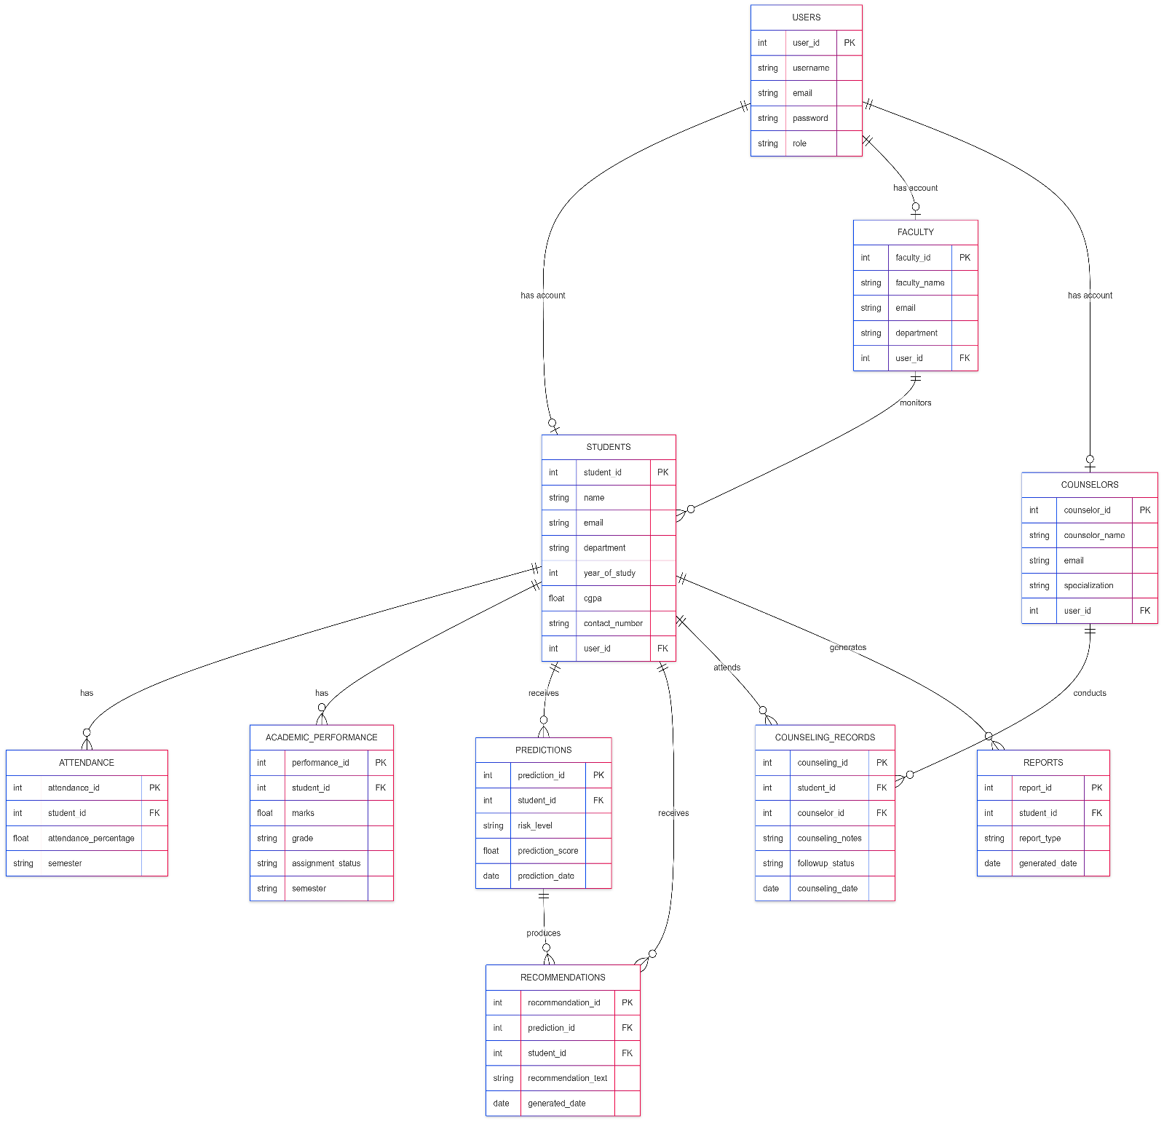

  - Entity:User
Attribute | Data Type | Constraints | Description
student_id | INT | PK, Auto Increment | Unique student identifier
user_id | INT | FK, NOT NULL | References Users table
name | VARCHAR(100) | NOT NULL | Student name
department | VARCHAR(50) | NOT NULL | Department name
year_of_study | INT | NOT NULL | Current academic year
contact_number | VARCHAR(15) | NOT NULL | Student contact number
cgpa | DECIMAL(3,2) | NULL | Current CGPA
  - Entity:Student
Attribute | Data Type | Constraints | Description
student_id | INT | PK, Auto Increment | Unique student identifier
user_id | INT | FK, NOT NULL | References Users table
name | VARCHAR(100) | NOT NULL | Student name
department | VARCHAR(50) | NOT NULL | Department name
year_of_study | INT | NOT NULL | Current academic year
contact_number | VARCHAR(15) | NOT NULL | Student contact number
cgpa | DECIMAL(3,2) | NULL | Current CGPA
  - Entity: Attendance
Attribute | Data Type | Constraints | Description
attendance_id | INT | PK, Auto Increment | Unique attendance record
student_id | INT | FK, NOT NULL | References Students table
attendance_percentage | FLOAT | NOT NULL | Attendance percentage
semester | VARCHAR(20) | NOT NULL | Semester details
date_recorded | DATE | NOT NULL | Attendance update date
  - Entity: Dropout_Prediction
Attribute | Data Type | Constraints | Description
prediction_id | INT | PK, Auto Increment | Unique prediction record
student_id | INT | FK, NOT NULL | References Students table
risk_level | VARCHAR(20) | NOT NULL | Low, Medium, High
risk_score | FLOAT | NOT NULL | Predicted risk percentage
prediction_date | DATE | NOT NULL | Prediction generation date
  - Entity: Counseling_Record
Attribute | Data Type | Constraints | Description
counseling_id | INT | PK, Auto Increment | Unique counseling session
student_id | INT | FK, NOT NULL | References Students table
counselor_id | INT | FK, NOT NULL | References Counselor table
session_date | DATE | NOT NULL | Counseling session date
recommendation | TEXT | NOT NULL | Counseling advice
status | VARCHAR(20) | NOT NULL | Pending, Completed

DAY-8 | DATABASE SCHEMA CREATION | June 07,2026
CREATE DATABASE IF NOT EXISTS student_dropout_prediction_db;
USE student_dropout_prediction_db;
-- TABLE 1: USERS
CREATE TABLE users (
user_id INT AUTO_INCREMENT PRIMARY KEY,
name VARCHAR(100) NOT NULL,
email VARCHAR(150) UNIQUE NOT NULL,
password VARCHAR(255) NOT NULL,
role VARCHAR(20) NOT NULL
);
-- TABLE 2: STUDENTS
CREATE TABLE students (
student_id INT AUTO_INCREMENT PRIMARY KEY,
user_id INT NOT NULL,
department VARCHAR(50) NOT NULL,
year_of_study INT NOT NULL,
cgpa DECIMAL(3,2),
FOREIGN KEY (user_id) REFERENCES users(user_id)
);
-- TABLE 3: ATTENDANCE
CREATE TABLE attendance (
attendance_id INT AUTO_INCREMENT PRIMARY KEY,
student_id INT NOT NULL,
attendance_percentage FLOAT NOT NULL,
FOREIGN KEY (student_id) REFERENCES students(student_id)
);
-- TABLE 4: DROPOUT_PREDICTION
CREATE TABLE dropout_prediction (
prediction_id INT AUTO_INCREMENT PRIMARY KEY,
student_id INT NOT NULL,
risk_level VARCHAR(20) NOT NULL,
risk_score FLOAT NOT NULL,
prediction_date TIMESTAMP DEFAULT CURRENT_TIMESTAMP,
FOREIGN KEY (student_id) REFERENCES students(student_id)
);
-- TABLE 5: COUNSELING_RECORD
CREATE TABLE counseling_record (
counseling_id INT AUTO_INCREMENT PRIMARY KEY,
student_id INT NOT NULL,
counselor_name VARCHAR(100) NOT NULL,
recommendation TEXT,
session_date DATE,
FOREIGN KEY (student_id) REFERENCES students(student_id)
);
-- TABLE 6: REPORTS
CREATE TABLE reports (
report_id INT AUTO_INCREMENT PRIMARY KEY,
report_type VARCHAR(50) NOT NULL,
generated_date TIMESTAMP DEFAULT CURRENT_TIMESTAMP );

DAY-9 | UI WIREFRAME DESIGN | June 07,2026
  - 1.Register Page
+-----------------------------------------------+
| |
| AI DROPOUT PREDICTION SYSTEM |
| |
|-----------------------------------------------|
| CREATE ACCOUNT |
| |
| Full Name |
| +----------------------------+ |
| |
| Email Address |
| +----------------------------+ |
| |
| Select Role |
| +----------------------------+ |
| |
| Password |
| +----------------------------+ |
| |
| Confirm Password |
| +----------------------------+ |
| |
| [ CREATE ACCOUNT ] |
| |
| Already have an account? Sign In |
| |
+-----------------------------------------------+
  - 2.Prediction result page
+--------------------------------------+
| PREDICTION RESULT |
+--------------------------------------+
| |
|Student Name |
| |
|Risk Score |
| |
|Risk Level |
| |
|Risk Factors |
| |
|Recommended Actions |
| |
| [ Request Counseling ] |
| |
+--------------------------------------+
  - 3.Counseling Request Page
+--------------------------------------+
| COUNSELING REQUEST |
+--------------------------------------+
|Student Name |
| |
|Select Counselor |
| |
|Select Date |
| |
|Select Time |
| |
|Reason |
| |
| [ Submit Request ] |
| |
+--------------------------------------+

DAY-10 | LOGIN & DASHBOARD UI DESIGN | June 07,2026
  - 10.1-Login Page
+-------------------------------------+
| LOGIN PAGE |
+----------------------------------+
| Select Role ▼ |
| Enter Email Address |
| Enter Password |
| Forgot Password? |
|[ Get Started ] |
+--------------------------------------+
  - 10.2-Dashboard components
The dashboard may vary based on the role they have choosing during their login process or register page
Student Dashboard | Counselor Dashboard | Faculty Dashboard
View prediction results | Review at-risk students | Monitor academic performance
Request counseling | Manage counseling sessions | Track attendance
View notifications | Schedule counseling | View risk indicators
View profile | Generate counseling reports | Monitor student progress

DAY-11 | NAVIGATION & FORM DESIGN | June 07,2026
  - 11.1-Navigation Structure
Route | Page | Access
/ | Landing Page | Public
/login | User Login Page | Public
/dashboard | Dashboard | Protected (All Users)
/students | Student Management | Administrator, Faculty
/attendance | Attendance Management | Faculty
/prediction | Dropout Prediction | Administrator, Faculty
/risk-students | At-Risk Students List | Counselor, Administrator
/counseling | Counseling Recommendations | Counselor
/progress | Student Progress Tracking | Counselor, Student
/reports | Reports & Analytics | Administrator
/profile | User Profile | Protected
/logout | Logout | Protected

DAY-12 | DESIGN REVIEW | June 07,2026
  - 12.1-Activities Performed
• Reviewed the system architecture and overall project design.
• Analyzed the Use Case Diagram and actor interactions.
• Reviewed the Entity Relationship (ER) Diagram and database schema.
• Evaluated the navigation structure and user flow.
• Reviewed UI wireframes and form designs.
• Validated functional requirements against the proposed design.
• Identified potential improvements in usability and system structure.

  - 12.2-Design Summary
To evaluate the activities from June 01 to June 11,2026 such as system design,database structure,user interface design and navigation flow
Design Component | Details Reviewed | Status
System Architecture | Overall structure and module interaction | Reviewed
Use Case Diagram | Actors, use cases, and system functionalities | Reviewed
Functional Requirements | Verification of system features and requirements | Reviewed
Database Design | Entities, attributes, and relationships | Reviewed
ER Diagram | Entity relationships and database structure | Reviewed
Database Schema | Tables, primary keys, foreign keys, and constraints | Reviewed
Navigation Design | User flow and page accessibility | Reviewed
Form Design | Input fields, validation rules, and usability | Reviewed
UI Wireframes | Layout, screen organization, and user experience | Reviewed
AI Prediction Module Design | Data inputs, prediction process, and output structure | Reviewed
Counseling Module Design | Recommendation and intervention workflow | Reviewed
Reports & Analytics Design | Dashboard and reporting functionality | Reviewed

DAY-13 | FRONTEND SETUP | June 07,2026
  - 13.1-Environment Setup
# Create React Project using Vite and navigating to the Project Folder and installing dependencies
npm create vite@latest frontend -- --template react
cd frontend
npm install

# Install React Router and tailwind CSS
npm install react-router-dom
npm install -D tailwindcss @tailwindcss/vite

# Install React icons
npm install react-icons

  - 13.2-Frontend Folder setup
frontend/
├── node_modules/
├── public/
├── src/
│ ├── assets/
│ │ ├── backgroundimage.jpeg
│ │ ├── react.svg
│ │ ├── referenceimage.jpg
│ │ ├── add.jpg
│ │ ├── Altered.jpg
│ │ └── vite.svg
│ │
│ ├── components/
│ │ ├── Dashboard.jsx
│ │ ├── Navbar.jsx
│ │ └── Sidebar.jsx
│ │
│ ├── pages/
│ │ ├── CounsellorDashboard.jsx
│ │ ├── FacultyDashboard.jsx
│ │ ├── Login.css
│ │ ├── Login.jsx
│ │ └── Register.jsx
│ │
│ ├── App.css
│ ├── App.jsx
│ ├── index.css
│ └── main.jsx
│
├── .gitignore
├── eslint.config.js
├── index.html
├── package-lock.json
└── package.json

  - 13.3-Deliverables
- React Project Created
- Frontend Environment Configured
- Required Dependencies Installed
- Routing Setup Completed

